7/6/2019

Manual Strategy

Machine Learning for Trading

Josh Adams

CS 7646: Machine Learning for Trading

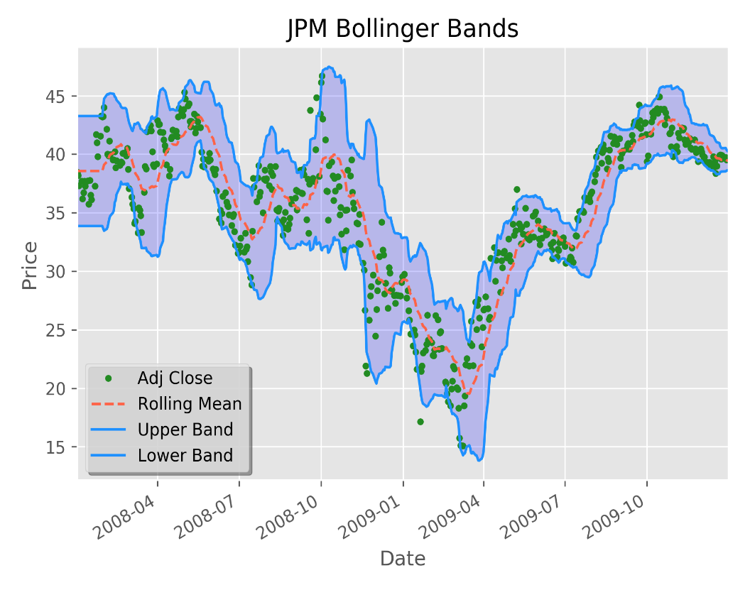Technical Indicators are used to predict the future movements of stock. I used Bollinger bands, Relative Strength Index and Simple Moving Average to attempt to predict the future of the stock and to maximize profits.

**Simple Moving Average** is stock indicator where a rolling average is taken with a specified window and the stock adjusted close.

**Bollinger Bands** is an indicator of stock trends. Bollinger Bands is a range, typically two standard deviations above and below the SMA.

Looking at the chart you can see that almost all the values fall within the upper and lower Bollinger band. When a stock price is outside the band, it can be used as an indicator of either a buy or sell depending on which band the value falls. An example of a data point falling outside the bands would be around 2010-04. The point is above the upper bound of the band which should be used to indicate to the traded it is time to sell as it is unlikely the stock price will continue to rise. Since Bollinger bands are calculated based on the SMA, we must get that information first. The SMA can easily be calculated using Pandas rolling_mean function. This requires the prices and a window to be specified when calling. The window can be changed to whatever value the trader prefers, but typically is dependent on the amount of data the trader has. If you only have 100 price data points then a rolling mean of 50 is probably a bad idea, while if you have 100,000 data points of 50 would not be a bad idea. Rolling mean takes the previous N number of price data points and takes the average of those points, N being the window size. The larger the window size, the smoother the SMA becomes, this allows for compensation of anomalies but too large will reduce the amount of practical information gained.

**Relative Strength Index** is a momentum oscillator that measures the speed and change of price movements. The RSI will move between 0 and 100 with traditional signals within that range. When the RSI is above 70 it is considered overbought and when below 30 oversold. Calculating the RSI, required you to get all the days where the price changes. You then take the exponential moving average of those data points that increase and those that decrease. Then the average of that moving average where the prices increased divided by the average of the 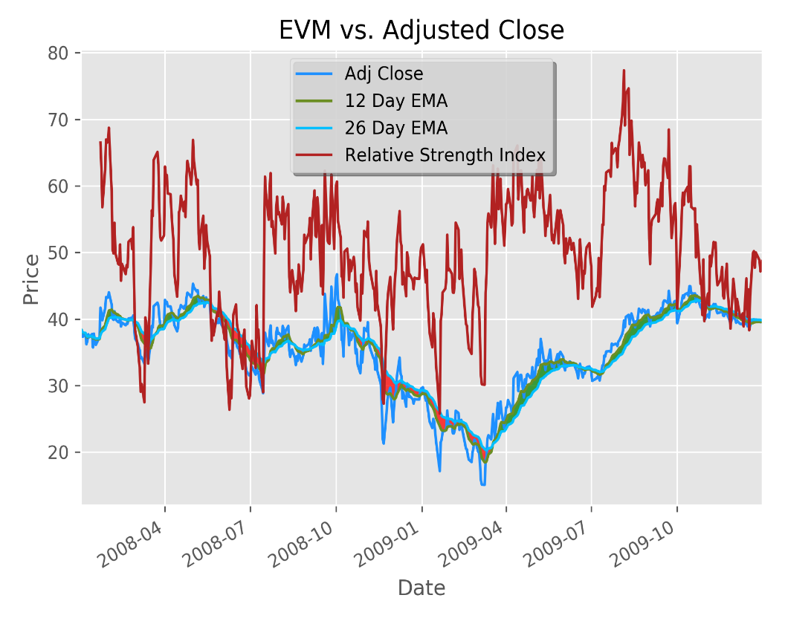moving average where the price decreased. This will produce the relative strength of the stock, which is necessary to calculate the relative strength index. The generally accepted formula for the relative strength index is:

. The level of the RSI is a measure of the stocks recent trading strength. When stocks are in the threshold of either being oversold or overbought, the stock will typically change directions. Looking at the chart ‘EVM vs Adjusted Close’, around 2010-04 the RSI is very high and very shortly after going above 70 the price drops.

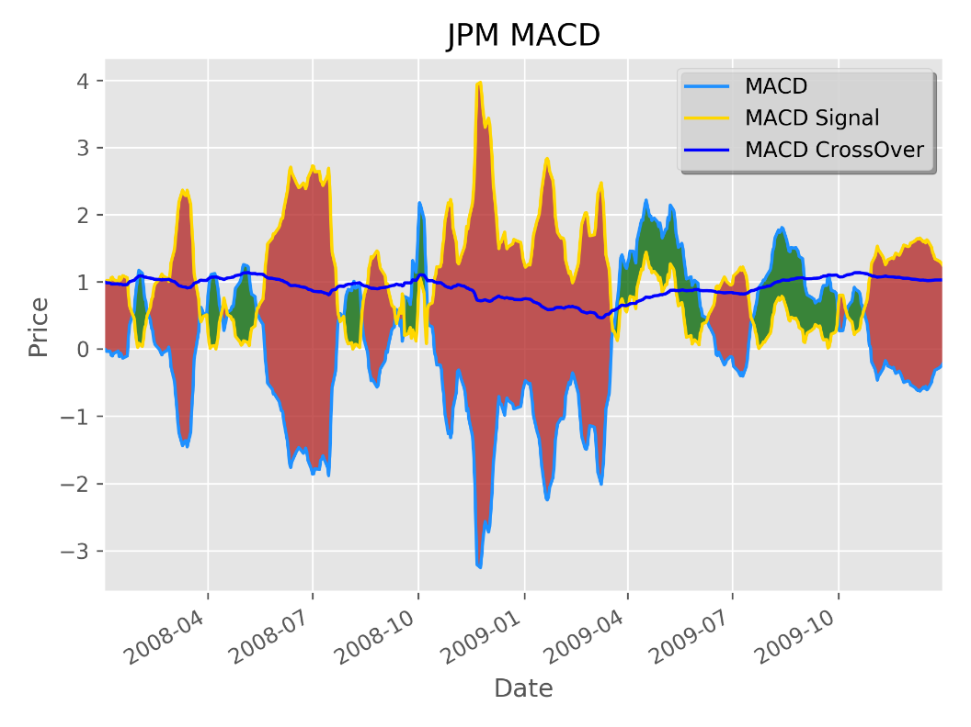MACD is the moving average convergence divergence stock indicator. The MACD is a 12-day exponential moving

average minus a 26-day EMA. The signal for the MACD is another exponential moving average based around a 9-day window. When the MACD moves above the signal this is an indication of what type of market the stock is currently experiencing, such as a bullish or bear market. I highlighted the areas where the MACD is above the Signal in green and red where it is below.

Momentum is another indicator used to predict future movements of a stocks price. This is sometimes referred to as the velocity of a stocks price change.

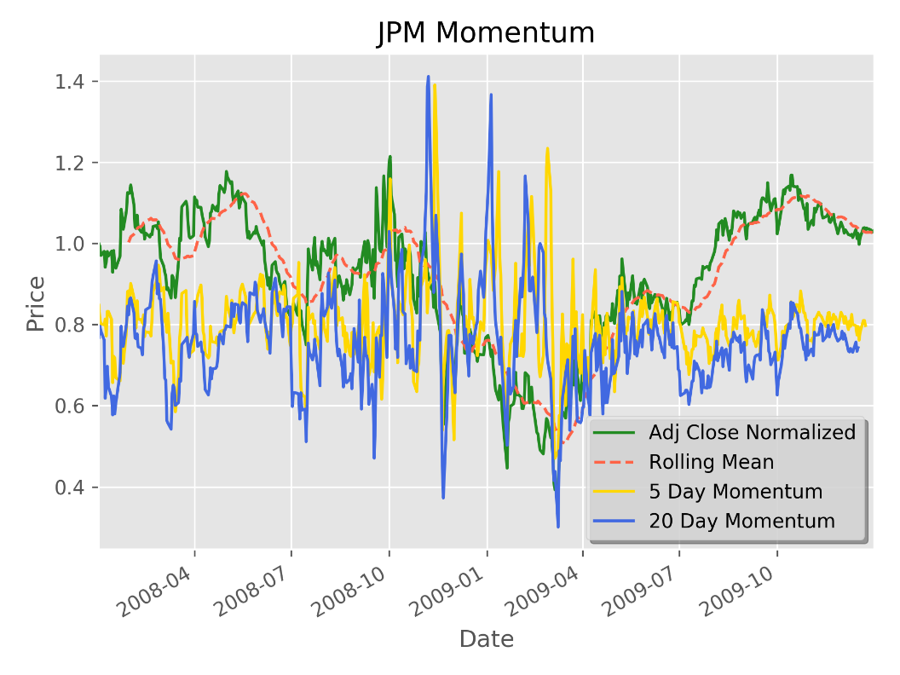 and in my chart a 5- and 20-day period is used. To calculate momentum I used a dataframe shift of 5 and 20. This essentially shifted the frame back 5 and 20 respectively to that price. I then divide the current price dataframe by the shifted frames to get the values of the momentum of the 5 -and 20day shifts. In the chart ‘JPM Momentum’, I artificially shifted the 5- and 20-day momentum downward to better visualize the correlation between the momentums and the price for the stock. Such as on 2011-07 the price increased very quickly and that is shown in both momentums.

On-Balance Volume is a stock indicator which considers the volume the stock has. OBV is calculated by first looking at the current price.

If the current price is above the previous price then:

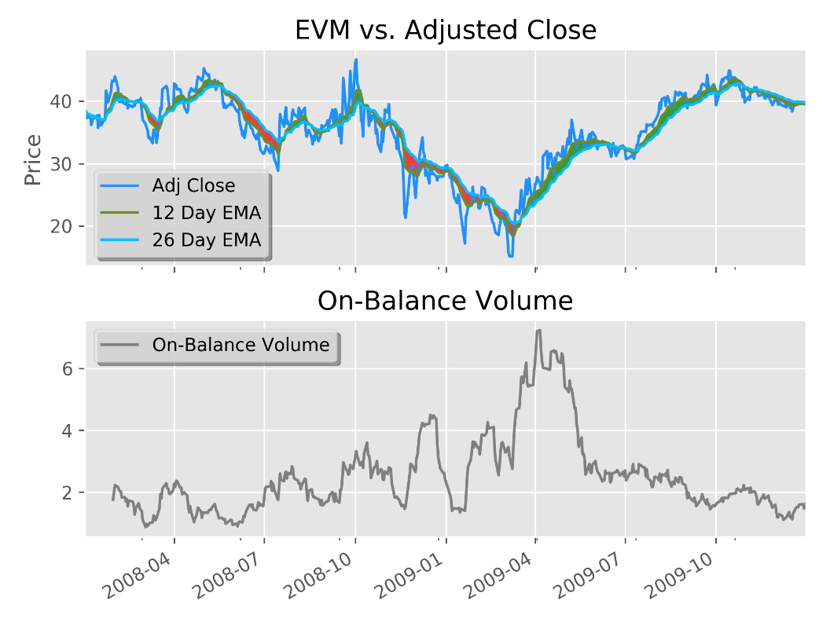ELSE

If the prices are equal then you just take the previous OBV as the current OBV. OBV can be used to confirm price trends or predict price movements because volume changes correlate to price changes. A way to predict movements of stock using the OBV is if you see an increase in price but a decrease in volume, would suggest a loss of interest in that stock. Which could mean to sell your stocks soon but more information is needed such as other indicators.

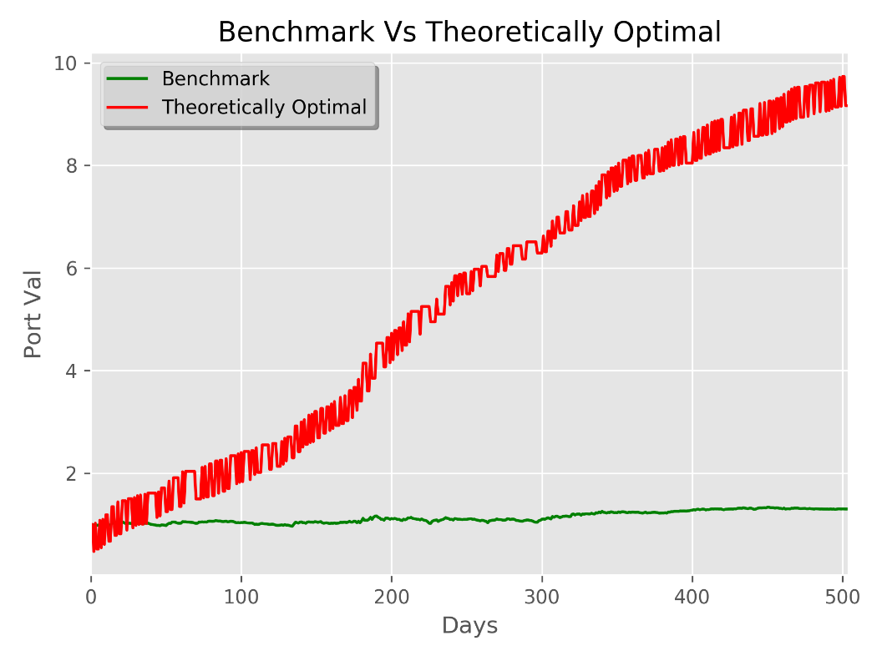

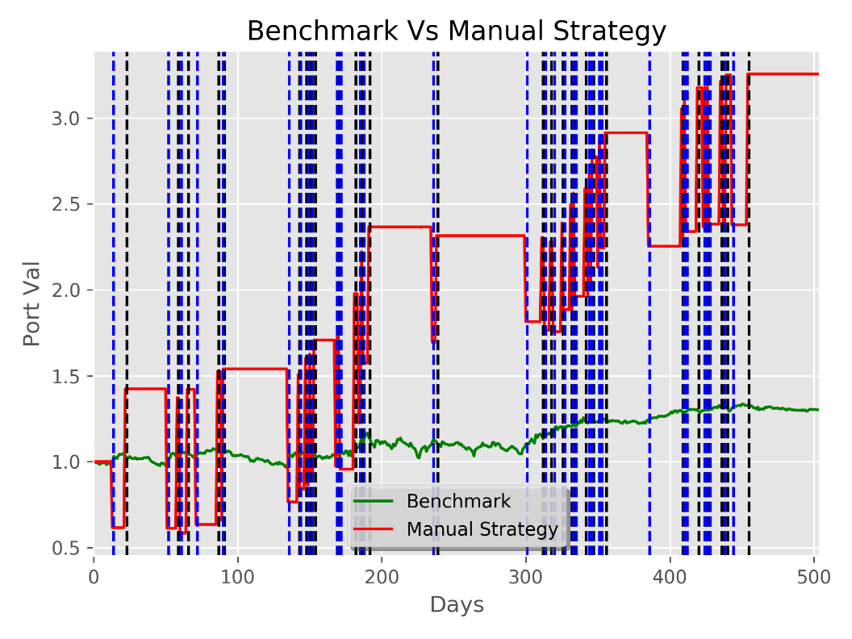Theoretically Optimal versus a benchmark. The benchmark is a purchase of 1000 shares of JPM and holding for the remainder of the time frame. This is not very effective as your only returns are specifically from then 1000 shares and their prices increasing or decreasing. Having normalized the data it makes it much easier to see how much better the theoretically optimal solution is. The problem with this is that the theoretically optimal solution is dependent on future knowledge, e.g. the price of the stock on the next trading day. The standard deviation of daily returns for the benchmark was 0.02, and for the optimal strategy it was 0.02. The cumulative returns for the benchmark was

-0.017 and for the optimal strategy it was 3.48. The average of the daily returns for the benchmark was -0.00015 and for the optimal strategy it was 0.106, which was significantly better.

Manual Strategy is a rule-based implementation of a stock trader based on stock indicators. I used Bollinger Band, Relative Strength Index and Simple Moving Average to determine whether to buy or sell. I set thresholds for those values and if they stocks value for those was not within those thresholds it would indicate the stock should be sold or bought. For each row in my dataframe I have the values already calculated for the Bollinger Band, Relative Strength Index and Simple Moving Average. My first check is to see if the Bollinger Band Percentage is less than the threshold, I have set of 0.6. If it is, I check the RSI and if greater than the threshold for that 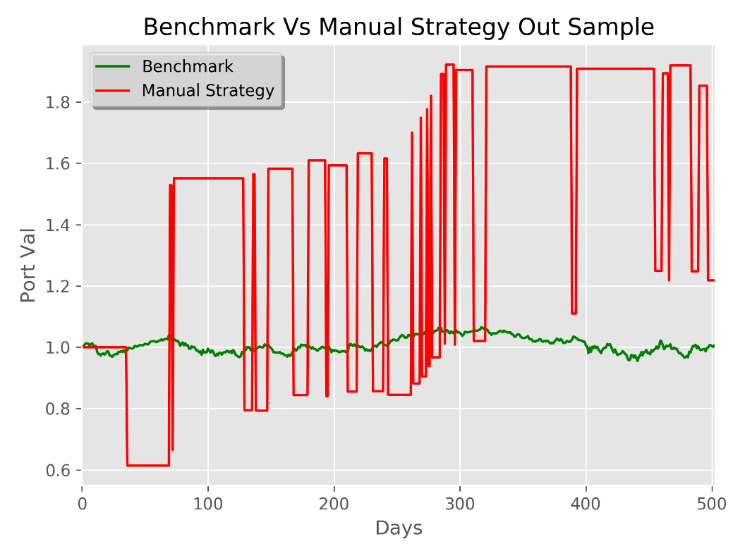of 45. If the RSI is within that threshold, I check the Simple moving average against my

threshold of 0.95. All checks needed to pass for a signal of a buy or sell to occur.

Comparative Analysis will be an example of out of sample data to evaluate the manual strategy. This is an example of the manual strategy vs the benchmark on the in-sample data of January 1,2008 to December 31, 2009. I was not able to have the x Axis display the dates because I get kept getting an error regarding converting ordinal. Plotting with the dates along the bottom worked for the prior charts but for Manual Strategy and Theoretically Optimal it was causing issues. The manual strategy did out perform the benchmark but was significantly outperformed by the theoretically optimal strategy. My manual strategy did not perform as well on the out-of-sample data because I could dynamically change my thresholds to achieve better performance on the in-sample data. The out-of sample performance is based on a set of rules created for different data.

|  |  |  |  |  |
| --- | --- | --- | --- | --- |
|  | RSI | BBP | SMA | Daily_Rets |
| In-Sample | 48.845 | 0.479 | 0.976 | 0.017 |
| Out-Sample | 47.814 | 0.483 | 0.971 | 0.014 |